|  |  |
| --- | --- |
|  | Program Doktor Program Studi Teknik Geomatika  Departemen Teknik Geodesi  Program Pascasarjana Fakultas Teknik Universitas Gadjah Mada |

**Form Penilaian Seminar 2**

|  |  |  |
| --- | --- | --- |
| **Nama** | : | {Nama} |
| **NIM** | : | {NIM} |
| **Judul Disertasi** | : | {JudulDisertasi} |
| **Pelaksanaan Ujian** | : | {Tanggal} |

|  |  |  |
| --- | --- | --- |
| **No** | **Kriteria Penilaian** | **Nilai** |
| 1 | Hasil Penelitian (CPMK 2/ CPL c, d, CPMK 3/ CPL e, f) | {Skor1} |
| 2 | Penguasaan materi, yang ditunjukkan saat presentasi dan tanya-jawab (CPMK 1/ CPL a, b, CPMK 4/ CPL g) | {Skor2} |
| **Rata-rata** | | **{Rata}** |

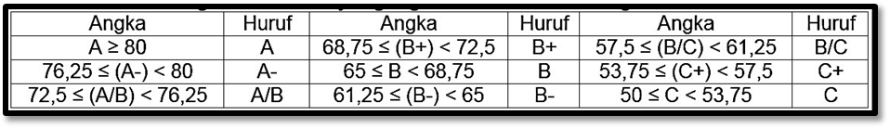

|  |  |
| --- | --- |
|  | Penguji, |
|  |  |
|  | {NamaDosen} |

|  |  |
| --- | --- |
|  | Program Doktor Program Studi Teknik Geomatika  Departemen Teknik Geodesi  Program Pascasarjana Fakultas Teknik Universitas Gadjah Mada |

**Lampiran**

**Komentar/ Saran Perbaikan**

**Seminar 2**

|  |  |  |
| --- | --- | --- |
| **Nama** | : | {Nama} |

|  |
| --- |
| 1. **KOMENTAR** |
| {Komentar} |
| 1. **SARAN PERBAIKAN** |
| {Saran} |

|  |  |
| --- | --- |
|  | Yogyakarta, {Tanggal} |
|  | Penguji, |
|  |  |
|  | {NamaDosen} |